Eclipse的ServersTomcat服务器配置问题

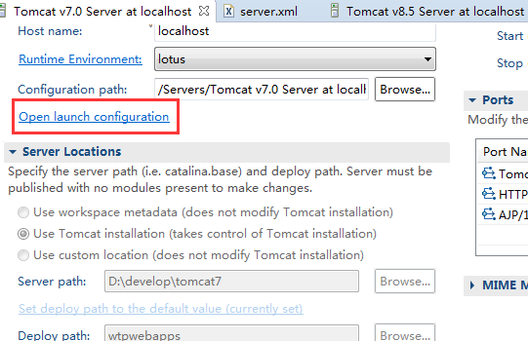

点击“Open launch configuration”，配置。

**进入虚拟机的配置**：

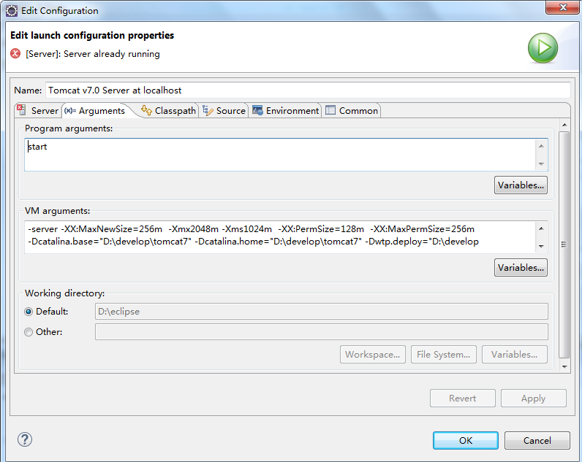

-server -XX:MaxNewSize=256m  -Xmx2048m -Xms1024m  -XX:PermSize=128m  -XX:MaxPermSize=256m -Dcatalina.base="D:\develop\tomcat7" -Dcatalina.home="D:\develop\tomcat7" -Dwtp.deploy="D:\develop\tomcat7\wtpwebapps" -Djava.endorsed.dirs="D:\develop\tomcat7\endorsed"

-server -XX:MaxNewSize=256m -Xmx2048m -Xms1024m -XX:PermSize=128m -XX:MaxPermSize=256m -Dcatalina.base="D:\EclipseWorkSpace\.metadata\.plugins\org.eclipse.wst.server.core\tmp1" -Dcatalina.home="D:\develop\apache-tomcat-7.0.85" -Dwtp.deploy="D:\EclipseWorkSpace\.metadata\.plugins\org.eclipse.wst.server.core\tmp1\wtpwebapps" -Djava.endorsed.dirs="D:\develop\apache-tomcat-7.0.85\endorsed"

-server -XX:MaxNewSize=256m -Xmx2048m -Xms1024m -XX:PermSize=128m -XX:MaxPermSize=256m

-Dcatalina.base="D:\develop\tomcat7" -Dcatalina.home="D:\develop\tomcat7" -Dwtp.deploy="D:\develop\tomcat7\wtpwebapps" -Djava.endorsed.dirs="D:\develop\tomcat7\endorsed"